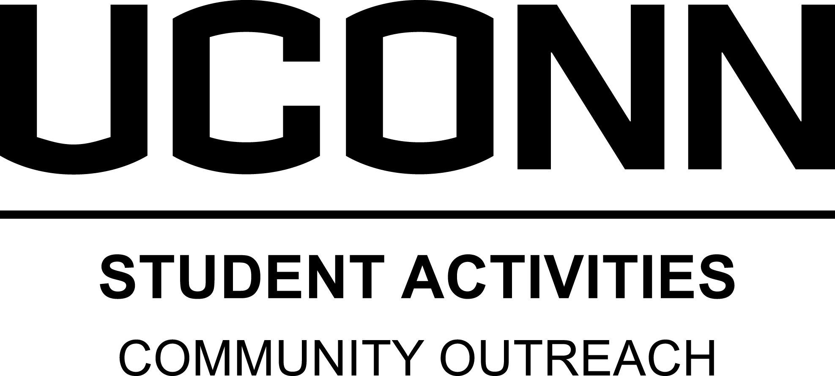
Program Director, English Language Learners
Position Description

Position Summary

English Language Learners (ELL) Literacy Program matches UConn students with non-English speaking individuals in the local area within a classroom setting. Participants help ESL clients develop English language communication skills. Program directors are responsible for the overall management and coordination of a designated Community Outreach (CO) program or project. Specific tasks and obligations for each program vary depending on the program; however, the following responsibilities are required of all program directors.

Major Duties and Responsibilities

- Program Management and Development
  - Review mission statement and revise as needed
  - Develop appropriate goals
  - Contact and meet accordingly with site supervisor(s)
  - Serve as a liaison between participants and site supervisor(s)
  - Implement service activities that meet the self-identified needs of clients; create appropriate materials, engage participants in service delivery, and access external resources as needed
  - Communicate and meet regularly with designated CO staff member and site supervisor(s)

- Volunteer Management
  - Recruit, screen, train and support volunteer and work study participants
  - Prepare participants through orientation and training workshops to achieve program’s objectives; organize meetings, develop training materials, and facilitate activities
  - Provide ongoing monitoring and supervision of participants
  - Communicate regularly with participants regarding scheduling, transportation, activity planning, payroll, and other related program functions
- Recognize participants for their contributions
- Organize opportunities for participants to reflect on their experiences

- Administrative Tasks
- Attend all related CO meetings, trainings, seminars, and workshops
- Manage any financial or other resources including budgeting, purchasing, and tracking
- Collect and update data related to programs, membership, and service hours
- Schedule and monitor transportation
- Represent CO at University classes, meetings, or events
- Perform other related duties and activities to support the program and the Office of Community Outreach, as needed

- Project Teams
  - Participate in a CO project team including: program management, professional development, or community building

- Program Participation
  - Program Directors are expected to participate in their program on a regular schedule as decided with their staff supervisor

Qualifications

- Minimum Qualifications:
  - Strong interest in and commitment to community service
  - At least one year related experience working with ESL clients in tutoring or other capacity
  - One semester or more of related experience in a leadership and/or supervisory position
  - A strong appreciation for, as well as willingness to work with and support, demographically diverse and traditionally underrepresented and oppressed groups (e.g. race, cultural, gender, ability, and sexual orientation)
  - Ability to positively represent CO to the University and external community
  - Proficient interpersonal, relationship, and partnership building skills
  - Ability to effectively convey oral and written communication
  - Strong organizational and administrative skills
  - Demonstrated basic knowledge and skill in the use of personal computers and basic software programs such as Microsoft Office Word and Excel
  - Ability to work independently, assess programmatic needs, and develop creative solutions
  - Capacity to facilitate individual and group supervisory meetings including conflict resolution/problem solving
  - Willingness to work irregular and flexible hours including evenings and weekends
  - Student must not be on academic probation and maintain academic standing in accordance with the Department of Student Activities Student Leader Eligibility Policy (less than a 1.8 semester GPA for 1-23 credits, or less than a 2.0 semester GPA for 24+ credits)

- Preferred Qualifications:
  - At least one year experience with ESL Family Literacy Program
  - One year related experience in a leadership and/or supervisory position
  - Excellent computer skills with an emphasis on Microsoft Office Word and Excel

Commitment

- Full academic year commitment is required
- Participation in CO training in August the week before Fall Semester begins
- 10-12 hours per week; exact hours and schedule will fluctuate and are flexible to student’s academic schedule

The University of Connecticut is an Equal Opportunity Employer and supports all state and federal laws that promote equal opportunity and prohibit discrimination. In keeping with our commitment to build a culturally diverse community, the University of Connecticut encourages applications from women, veterans, people with disabilities and members of traditionally underrepresented populations.

